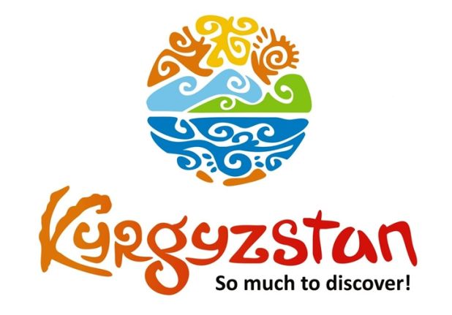**Tour to Kyrgyzstan for 20 days**

Country: **Kyrgyzstan**

Period: **June - September**

**Days: 20 / Nights: 19**

Organizing any complexity of tours to Issyk-Kul, Son-Kul, around Kyrgyzstan and Central Asia. We guarantee you high quality of service and individual approach!

Spend 20 unforgettable days in Kyrgyzstan and get to know real nomadic lifestyle. You will be able to visit such places as Issyk-Kul, Son-Kul and Arslanbob forests. Additionally, our guests will be able to taste national cuisine and many more.

#### [Day 1: Airport - Bishkek (30 km/50 min)](https://concept.kg/en/tours/inbounds/15/#program_collapse_58)

#### 

Upon arrival to Bishkek meet a local guide and transfer to the city of Bishkek.  
Sightseeing tour of Bishkek or full-day free.  
Standard check-in to a boutique hotel which is ideal for a family stay (after 14:00pm).

Meals: no

#### [Day 2: Bishkek - Chon-Kemin (135 km/3 h)](https://concept.kg/en/tours/inbounds/15/#program_collapse_59)

In the morning meet your guide and driver and depart towards Chon-Kemin Valley.  
On the way, visit Burana Historical Tower, a small nearby Museum and open air Balbals (stone figures).   
Upon arrival to Kalmak-Ashuu village – accommodation at Ashu Eco Lodge.  
In the afternoon, excursion to Kalmak-Ashuu Gorge on a horse cart. Light trekking in the mountains and rest.  
Arrival to a guesthouse and rest inside of a green territory, take a walking tour around the village to find out more about countryside life and meet local people.  
Horseback riding available activities upon request.Lunch and dinner at the terrace on the second floor that has a panoramic view to surrounding mountains and village.

Meals: breakfast, lunch, dinner

#### [Day 3: Chon-Kemin - Issyk-Kul (180 km/3 h)](https://concept.kg/en/tours/inbounds/15/#program_collapse_60)

After the breakfast depart to the Northern shore of the Issyk-Kul Lake.  
On the way stop at the Tamchy village to visit local Kyrgyz family’s house to observe and participate in a Felt Craft Show. After the show, there is homemade lunch with the family members.  
Visit open air Petroglyphs Museum (stone inscriptions) and Rukh-Ordo Cultural Complex in Cholpon-Ata town.  
Check in to a family resort.  
Free time for rest and swimming in the afternoon.  
Dinner at the hotel.

Meals: breakfast, lunch, dinner

#### [Day 4: Issyk-Kul Lake](https://concept.kg/en/tours/inbounds/15/#program_collapse_61)

Full-day free

Boat tour available upon request.

Meals: breakfast, lunch, dinner

#### [Day 5: Issyk-Kul - Karakol (150 km/3 h)](https://concept.kg/en/tours/inbounds/15/#program_collapse_62)

#### 

Check-out from the hotel and departure for a half-day excursion to the Semenov Gorge.  
Easy trekking and rest.  
Open air picnic-lunch.

The Semenov Gorge is located 40 km away from the town of Cholpon-Ata. The river Ak-Suu, which starts from the glacier, flows in the valley. The slopes of the Gorge are covered with dense forests of the Tian Shan spruce trees and fragrant herbs. Rough rocks and dark green tall trees are perfectly combined with each other and together make up the landscape of extraordinary beauty. Among the attractions of the Semenov Gorge are the waterfalls at the headspring of the river Ak-Suu and the lake Syuttu-Bulak.

From the Gorge there is a drive along the scenic road towards Karakol, which is located in the Far East of the Issyk-Kul Lake.  
Just before reaching the town visit the museum of Przewalski.  
Accommodation in the guest house.  
Afternoon sightseeing tour of the old wooden Russian Church (built without nails), Dungan Mosque (Dungan’s are ethnic minority of Muslim Chinese, moved from the West of China) and Kupecheskiy Proezd street that resembles 19century old Russian village. Further, visit one-village-one-product local shop for handmade souvenir products made by local women of the region.  
Dinner at the local Uigur family’s house with Uigur food specialties

Meals: breakfast, picnic-lunch, dinner

#### [Day 6: Karakol - Altyn-Arashan Valley - Karakol (30 km/ 50 min)](https://concept.kg/en/tours/inbounds/15/#program_collapse_63)

#### 

Full-day excursion to the Altyn Arashan Valley with trekking in the mountains.  
Open air picnic-lunch.  
Vehicle will be changed for a heavy 4WD Truck since a normal passenger car is not able to drive up there.  
Altyn Arashan is located 20km away from the South-East of Karakol in an alpine valley dominated at its Southern end by the 4260m tall Pik Palatka (‘Tent Peak’). The valley forms part of the Arashan State Nature Reserve which is famous for its unique wildlife, including snow leopards and wild bears. Altyn Arashan, meaning ‘Golden Spa’ in Kyrgyz, is the most popular hike near Karakol in the North-East of the country.   
Arrival back to Karakol in the afternoon.  
Free time in the evening.

Meals: breakfast, picnic-lunch

#### [Day 7: Karakol - Jeti-Oguz - Kok-Jayik Valley (40 km/1 h)](https://concept.kg/en/tours/inbounds/15/#program_collapse_64)

After the breakfast departure  to Jeti-Oguz Valley. There are rock formations in the shape of the Broken Heart and Seven Bulls on the way. Visitors can climb up the hills in order to see the surrounding views.  
Next is a drive to Kok-Jayik, which is translated from Kyrgyz as ‘Green Pasture.’ It is a place where nomads settle down during the summer. Visitors stay in the Yurts.

Note:Accommodation conditions at yurt camp are very traditional, meaning that person will be able to share toilet outside of the yurt and be able to experience Kyrgyz rural lifestyle firsthand.

Meals: breakfast, lunch, dinner

#### [Day 8: Kok-Jayik Valley](https://concept.kg/en/tours/inbounds/15/#program_collapse_65)

Full-day free in the valley.

Possibility to take an easy hiking tour to the waterfall, visit nomads in their yurts and learn more about their every-day routine: cooking food, milking cows, preparing dairy products and taking care of the children.

Meals: breakfast, lunch, dinner

#### [Day 9: Kok-Jayik - Kochkor (280 km/4-5 h)](https://concept.kg/en/tours/inbounds/15/#program_collapse_66)

#### 

Drive through the Southern shore of the Issyk-Kul Lake to the Kochkor village.  
On the way excursion to Skazka (“Fairy Tale”) Canyon. Picnic-lunch there.  
The canyon was named after its bizarre rocky landscape, which for many years has been transformed by wind into various sculptures and formations. Some structures have been named for their similarity to well-known objects. For example, one set of ridges in the canyon is called the "The Chinese Wall" due to its similarity to the Great Wall of China. Visitors can also find what appear to be statues of a hippopotamus, snakes, dragons, sleeping giants and even whole castles. Not only do the rocks have different shapes, but also various colors.  
Visit Manzhyly-Ata Valley. On the Southern shore of the Issyk-Kul Lake, between the villages Kadji-Sai and Ton, is situated a unique place called Manzhyly-Ata. This place is famous for its number of healing springs which flow out of the ground. Therefore, people call it the "Valley of the Sacred Springs." Some of these springs are known as cures for various diseases. There are 17 major springs in total.  
Arrival to Kochkor village in the afternoon and accommodation at a friendly family-run guesthouse with basic conditions. Participate in preparing the dinner with the host.

Meals: breakfast, lunch-box, dinner

#### [Day 10: Kochkor - Song-Kul Lake (135 km/3 h)](https://concept.kg/en/tours/inbounds/15/#program_collapse_67)

#### 

In the morning visit Altyn-Kol (“Golden Hands”) local shop for felt products.  
Depart to the Song-Kul Lake.  
Enjoy the picturesque landscape, yurt camp, horses grazing the grass, rivers and nomads in their yurts.  
Visitors can stop on the way to meet local nomads who will invite to their yurts and give some bread and Kymyz (fermented mare’s milk).  
Upon arrival to Song-Kul, accommodation at the yurt camp with basic conditions.  
Afternoon free time for rest.

Meals: breakfast, lunch, dinner

#### [Day 11: Song-Kul Lake](https://concept.kg/en/tours/inbounds/15/#program_collapse_68)

Full day rest at the lake and hiking tour to nearby mountains.

Visitors have a chance to get to know Kyrgyz mountain nomads and their lifestyle. Possibility to watch them milking cows and mares, preparing dairy products from the milk and a national Kyrgyz drink Kymyz, cooking food and taking care of households. Even if the locals do not speak the foreign language, they will do their best to be hospitable and understanding.  
Overnight at the yurt camp.

*Meals: breakfast, lunch, dinner*

#### [Day 12: Song-Kul - Tash-Rabat (285 km/5 h )](https://concept.kg/en/tours/inbounds/15/#program_collapse_69)

#### 

Drive to Tash-Rabat. On the way, stop in the town of Naryn for a lunch at a local café.  
The Caravanserai Tash Rabat, the unique monument of the Middle Ages, is located in the valley of Kara-Koyun, 90 km from Naryn and 60 km from the village At-Bashi. The building was constructed of stone and lime and all the materials were assembled in the nearby valley. There are several legends about the origins of the architectural complex Tash-Rabat. The most probable theory is that the monument was built in the 15th century and served as a coaching inn for the merchants. Caravans went along the trade routes from the Chui and Ferghana valleys to Kashgar. The height of the Tash-Rabat building is more than 20 m, and there is a total of 31 rooms creating a labyrinth. On the background of the green meadows of the valley the Caravanserai looks like a powerful and unapproachable fortress.  
Upon arrival to Tash-Rabat, accommodation at the yurt camp with basic conditions.  
Excursion to the complex and walking tour to surrounding mountains.

Meals: breakfast, lunch, dinner

#### [Day 13: Tash-Rabat - Eki-Naryn - Naryn (215km/4h)](https://concept.kg/en/tours/inbounds/15/#program_collapse_70)

#### 

After the breakfast departure for the Eki-Naryn valley.  
The name of the valley Eki-Naryn when translated from the Kyrgyz means “Two Naryn.” Exactly at this place, large and small tributaries merge into the most powerful Naryn River. A National State Reserve “Salkyn-Tor” is formed there, where tall pine forests grow. Additionally, the reserve is inhabited by bears, wild boars, mountain goats and snow leopards.The main goal of establishing this national park is conservation of deers. The amazing virgin beauty of the nature of this region will not leave you indifferent.  
Depending on visitors’ choice, they can stay at the Eki-Naryn yurt camp for overnight or drive to Naryn (44km) and stay at a guesthouse there.

Meals: breakfast, lunch-box, dinner

#### [Day 14: Naryn - Kazarman (300km/8h)](https://concept.kg/en/tours/inbounds/15/#program_collapse_71)

This day will be long one, but very rewarding. The landscape is absolutely wild and unspoiled.  
Most parts of the roads were constructed during the Soviet times. Visitors will pass from the Northern to the Southern part of the country.  
Kazarman is a small rustic village. Visitors will stay at a family run guest house there.

Meals: breakfast, lunch-box, dinner

#### [Day 15: Kazarman - Osh (270 km/5 ч)](https://concept.kg/en/tours/inbounds/15/#program_collapse_72)

#### 

Visitors will drive to the second capital of Kyrgyzstan – city of Osh. On the way, there will be a stop in the Uzgen town which is famous for producing special type of rice.  
Later, visit the rice market and historical minaret. Visitors can also try the Uzgen plov (dish cooked from meat and rice) from a local café for lunch.  
Arrival to Osh, accommodation at a homestay.   
Free time in the evening.

Meals: breakfast, lunch

#### [Day 16: Osh](https://concept.kg/en/tours/inbounds/15/#program_collapse_73)

Full-day sightseeing excursion in Osh.

Half-day excursion to colorful Osh Bazaar (market), then walk through the Alisher Navoi Park and watch elderly people drinking tea and playing chess.  
In the afternoon, climb the Holy Suleiman Mountain and visit its cave museum, Silk Road Museum and Alymbek Datka Complex.  
Dinner at a local Uzbek family’s house with Uzbek food specialties.

Meals: breakfast, lunch

#### [Day 17: Osh - Arslanbob (215 km/4 h)](https://concept.kg/en/tours/inbounds/15/#program_collapse_74)

#### 

Depart to Arslanbob, which is a popular place for its well-known walnut forest. On the way, stop in Uzgen town to visit the Historical Uzgen Minaret and Mausoleum.  
Upon arrival to Arslanbap, accommodation at a local family-run guest house with basic conditions.  
Afternoon excursion to the walnut forest and waterfall.

Meals: breakfast, lunch, dinner

#### [Day 18: Arslanbob - Toktogul (400 km/5 h)](https://concept.kg/en/tours/inbounds/15/#program_collapse_75)

#### 

On the way to Toktogul pass through the Tash-Komur Hydro-Electric Station and the Toktogul reservoir.

In Toktogul accommodation at a friendly family-run guesthouse.

Meals: breakfast, lunch, dinner

#### [Day 19: Toktogul - Bishkek (300 km/7 h)](https://concept.kg/en/tours/inbounds/15/#program_collapse_76)

#### 

The road to Bishkek is one of the most picturesque ones. It goes along the Chu River and depicts the different sceneries: from snowy capped mountains to beautiful gorges and flat valleys. The highest altitude is at the Suusamyr Valley (3586m above the sea level) where nomads herd their livestock.

Lunch at a roadside café (fried fresh river fish is available).  
In Bishkek accommodation at boutique hotel ideal for family stays.  
Free time in the evening.  
Farewell dinner at a local restaurant.

Meals: breakfast, lunch

#### [Day 20: Bishkek - Airport (30 km/50 min)](https://concept.kg/en/tours/inbounds/15/#program_collapse_77)

#### 

Transfer to the Airport for the departure flight.

Check-out from the hotel before 12:00pm.

Meals: breakfast

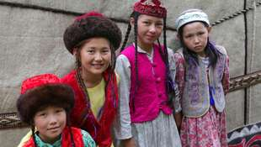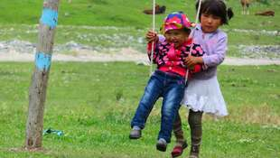

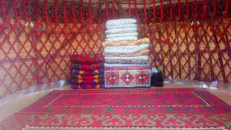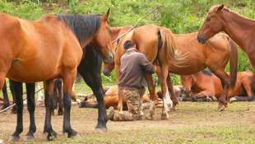

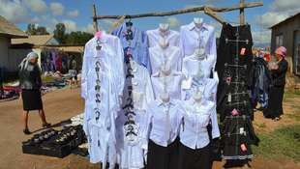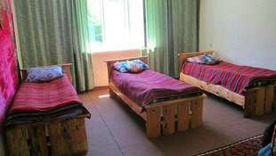

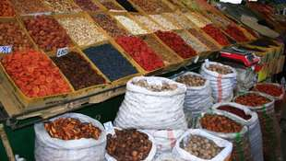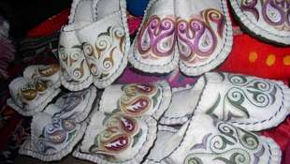

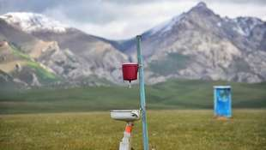

| **GROUP SIZE** | **PRICE IN USD/PER PERSON** |
| --- | --- |
| 2 | 4035 USD |
| 3-4 | 3355 USD |
| 5-6 | 2670 USD |
| Supplementary for single accommodation | 230 USD |

| **PRICE INCLUDES** |  |
| --- | --- |
| Twin based accommodation | Bishkek - 3* hotel (2 o/n) Chon-Kemin - guesthouse (1 o/n) Issyk-Kul - 3* hotel (2 o/n) Karakol - guesthouse (2 o/n) Jeti-Oguz - yurt camp (2 o/n) Kochkor - homestay (1 o/n) Son-Kul - yurt camp (2 o/n) Tash-Rabat - yurt camp (1 o/n) Naryn - guesthouse (1 o/n) Kazarman - homestay (1 o/n) Osh - homestay (2 o/n) Arslanbob - homestay (1 o/n) Toktogul - homestay (1 on) |
| *Note:* | *Toilet and shower with warm water are in the corridor for general use. Single accommodation can be arranged if there is some vacant space.  Standard accommodation for 3-6 people per room. Accommodation conditions at yurt camp are very traditional,  meaning that person will be able to share toilet outside of the yurt and be able to experience Kyrgyz rural lifestyle firsthand. Usually 3-6 pax per yurt (during the high season)* |
| Transport | Land transportation by air-conditioned non-smoking vehicle |
| Local guide services (Eng/Russ) | Included |
| Meals | Meals mentioned in the program |
| Entrance fees & excursions | Included |
| Felt craft making show in Tamchy village | Included |
| Water | 1 liter person/day |

| **PRICE EXCLUDES** |  |
| --- | --- |
| International flights | Not included |
| Visa/letter of invitation to Kyrgyzstan | Not included |
| Personal expenses | Not included |
| Early check-in, late/check-out on arrival/departure days | Not included but could be arranged upon request for additional fee |
| Meals other than stated/beverages with meals | Not included |
| Tips to guide/driver (optional) | Not included |
| Horseback riding in Chon-Kemin | USD 35 per horse USD 50 per instructor |
| Boat tour in Issyk-Kul Lake | USD 80/1 hour |

**Contact information:**

[www.travelscruiser.com](http://www.travelscruiser.com)

Phone (24/7): +996 …………., +996 ……….

E-mail: [info@travelscruiser.com](mailto:info@travelscruiser.com)